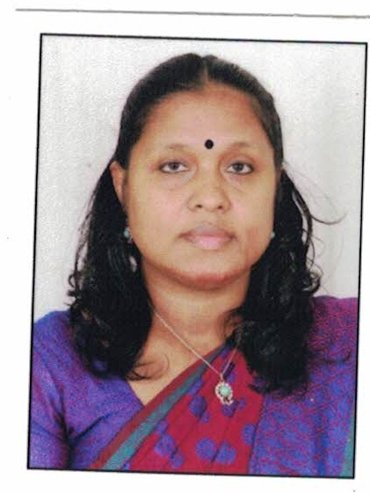

Name of the Teaching Staff | Rashmi.K.P
Designation | Assistant Professor
Department | Dept. of Economics
Date of Birth | 14-1-1979 |  | Date of Joining the Institution |  |  |  | 14-3-2011
Educational Qualification | UG – BA Economics with Actuarial Science |  | PG – Ma Economics |  |  |  |  |  | PhD –
Area of Interest | International Economics
Total Experience | Teaching –  11 Years |  | Industry – |  |  |  |  |  | Research –  3 Year
No. of Papers Published in Journals | National - nil |  | International - nil
No. of Papers Presented in Conferences | National – Nil |  | International - Nil
No. of Seminars / Workshops Attended | National- 5 |  | International-Nil
Programs Conducted | Conference: Nil  National :  International : |  | Seminar  National : 1  International : |  |  |  |  | Workshop - Nil
Trainings attended | Orientation -2 | Refresher  1 |  | FDP -2
Positions held at University Level | Board of Studies- |  |  | Curriculum Revision- 2 |  | Subject Expert |  |  |  | Any Other-
PhD Guide? Give field & University | Field:N.A |  | University : N.A
No. of PhDs / Projects Guided | PhDs - Nil |  | Projects at Masters Level: ONE
Books Published / IPRs/ Patents | Nil
Professional Memberships | Member- Kerala Economic Association
Consultancy Activities | Nil
Awards | Nil
Grants fetched | Minor Projects :1.35 Lakhs |  |  |  | Major Projects: Nil
Interaction with Professional Institutions | Nil
Workshops Attended
- Workshop on” CBCSS syllabus renewal” held in M. G. University, Kottayam, on August 8th 2011.
- Workshop in connection with the syllabus revision of Economics Ug Programmes under 2016 held on 3rd and 4th March 2016,at Mg University, Kottayam.
Orientation/ Refresher Programmes Attended
- UGC sponsored ‘Orientation Programme for Women Teachers /Councillors” Organised By The Dept Of Student Services at St. Xavier’s College for Women, Aluva on 30,July 2012.
- UGC Sponsored Orientation Programme Conducted UGC-Academic Staff College, University of Calicut From 16-01-2013 to 12-02-2013
- UGC Sponsored Special Summer School Conducted by UGC-HRDC, University of Calicut From 20.05.2016 to 09.06.2016
- One week FDP on 'The Dynamics of Research: Prospects, Reflections and Best Practices' organized under UGC – Scheme for Trans-Disciplinary Research for India's Developing Economy (UGC-STRIDE), Mahatma Gandhi University, Kerala, in association with IQAC, St. Xavier's College for Women, Aluva, from 1st to 7th July 2021.
- One week short term course titled Extrapolations through The Extraordinary: Broadening perspectives on magic and magicality organized by Department of Malayalam ,SSV college Valayanchirangara in association with MG University Kottayam ,14-18 December 2020.
Seminars attended:
- UGC Sponsored National seminar on Tourism and Sustainable Development In India- Ecological Perspectives and Issues” held at Newman College Thodupuzha, on 22-23 September 2015
- UGC Sponsored National seminar On “Emerging Trends in the Capiatal Market In India” held at St.Paul’s College, Kalamassery,Ernakulam on October 20th and 21st 2011
- UGC Sponsored Seminar on Music Organized by the Department of Student Services at SSV College Valayanchirangara, 28 September 2012
- UGC Sponsored National Seminar on “ Language Teaching Methodologies in Sanskrit” held at SSV College Valayanchirangara, 19-20 January 2012
- UGC Sponsored National Seminar on “Informal Sector in India: Lessons and Way Forward” held at St. Thomas College Thrissur, 14-15 November 2012
- UGC Sponsored National Conference on “Cyber Law and Cyber Forensics” held on 13th and 14th August, 2013 organised by the Department of Computer Science , SSV College, Valayanchirangara.
- UGC Sponsored National Seminar on “Wake up! Lets Arise! Awake! And Stop Not Till the Goal is Reached” organised by SSV College on 25th and 26th September 2014
- UGC Sponsored National Seminar On “ Role of corporate Social Responsibility On Modern Business Era” ” held at SSV College Valayanchirangara on 6th and 7th August 2015.
- UGC Sponsored National Seminar on Inclusive Growth and development in the Indian Context held at Morning Star Home Science College, Angamaly. on 23rd and 24th July ,2015
- UGC Sponsored National Seminar on “Infrastructure and Economic Development: Present Scenario, Challenges and Future Options” organised by Department of Economics, St Mary’s College, Thrissur on 15th and 16th September 2015
- One Week FDP on “Digital Technologies for E_Learning” Organised by Department of PhysicsSNM College Maliankara, Ernakulam in academic collaboration with Kerala State Higher Education Council Form 5-8-2021 to 11-08-2021
Minor Projects
- Affluence and diseases- Shifting burden of non- communicable diseases in Kerala funded by U G C

